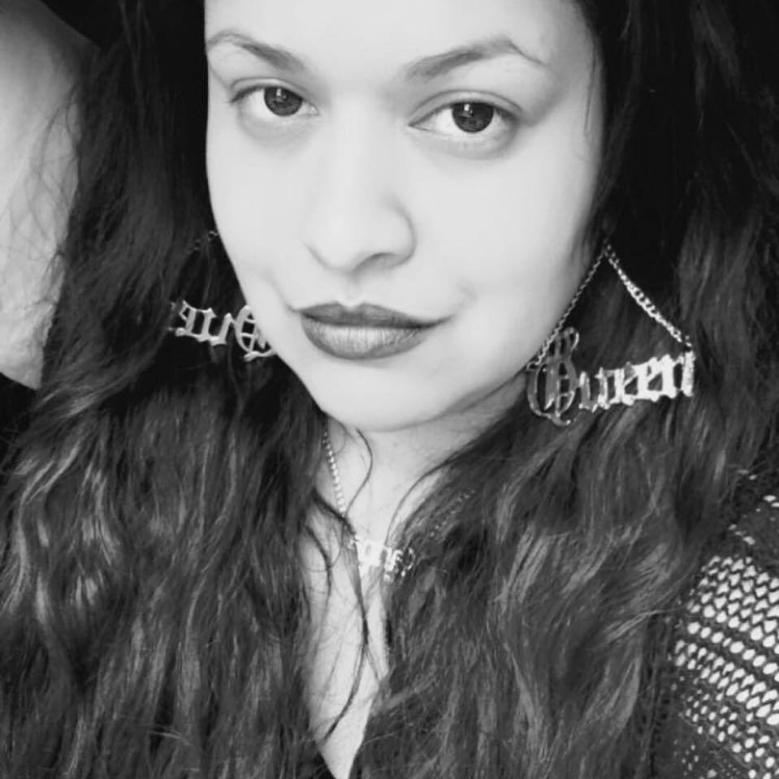  Contact InFO  Kglopez11@gmail.com  www.kglopez.com  347-393-3073  Publications  Books  Live Big Girl  Jewtina Journals  Pens, Pads and Poets  The Journals and Journeys of a Writer/Rider  Magazines:  Caiman Magazine  Poetica Magazine for Contemporary Jewish Writing  Tribes Magazine  Anthologies:  La Pluma y La Tinta New Voices  The Abuela Stories Project  The Full Circle Ensemble  The BX Files  Websites:  www.Bronxnet.org  www.Latintrends.com  www.Latinabookclub.com  www.thelatinoauthor.com | Karina Guardiola-Lopez  Author, Writer and Educator  BIOGRAPHY  Karina G-Lopez was born in the Bronx, raised in Queens and resides in East Harlem, New York City. She writer, author, poet, actor, teaching artist and educator. She obtained a B.A. from City College in English with a focus in Creative Writing and is currently working on her MSED at Baruch College. She is the author of several poetry books including: Jewtina Journals and Live Big Girl. Karina has been published and featured in various magazines, anthologies, venues, websites and on television and radio.  Education  Baruch College of New York – MSED: Currently Enrolled  City College of New York- Bachelor of Arts in English Education  Field Production Certificate- BronxNet  Studio Production Certificate - Manhattan Neighborhood Network  Editing Certificate – Manhattan Neighborhood Network  Acting– Victor Cruz Films  Notable Features  8th and 9th Annual Poetry Festival: Governor's Island  I Love Poetry: Nuyorican Poets Cafe  Reg E Gaines’ Showcase: Bowery Poetry Club  Live Big Girl, Three Women Show: National Black Theatre  Summer Reunion: East Harlem Culture Collective  Oye Mi Canto- Puerto Rican Relief: We Work Harlem  La Pluma y La Tinta's Latino Narrative: The New School  Full Circle Ensemble's Misconceptions: The National Black Theater  Robles Writes' The Abuela Stories Project: The Bronx Museum  Live Big Girl: Bronx Academy of Dance and Arts  Q-Boro Literature Crawl: Queens Book Fest at Republic

